Netflix Originals Data Exploration and Analysis
To convert Excel file into CSV and create a database using USE keyword named as Netflix and go-to table import csv file from desktop.
Task 1:
Retrieve all Netflix Originals with an IMDb score greater than 7, runtime greater than 100 minutes, and the language is either English or Spanish.
Query:

select * from netflix_originals where Language in ('English','Spanish') AND IMDBScore>7 and Runtime>100;
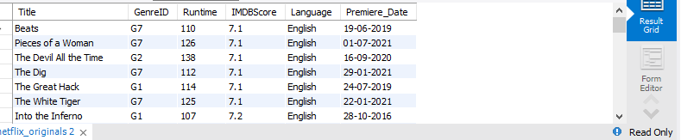
Task 2:
Find the total number of Netflix Originals in each language, but only show those languages that have more than 5 title.
QUERY:
select Language,count(*) from netflix_originals group by Language having count(Title)>5;
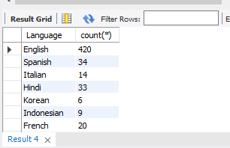

Task 3:
Get the top 3 longest-running movies in Hindi language sorted by IMDb score in descending order.

QUERY:
select Title,Language,Runtime, IMDBScore from netflix_Originals where Language="Hindi" order by Runtime Desc, IMDBScore desc limit 3;
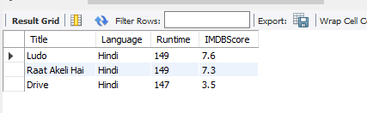

TASK 4:
Retrieve all titles that contain the word "House" in their name and have an IMDb score greater than 6.
Query:
Select Title from netflix_originals where Title like '%house%' And IMDBScore>6;

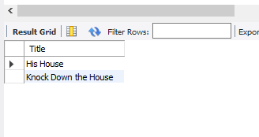
TASK 5:
Find all Netflix Originals released between the years 2018 and 2020 that are in either English, Spanish, or Hindi.
Query:
Select * from netflix_originals where Premiere_date between '01-01-2018' and '31-12-2020' And Language in('English','Spanish','Hindi');
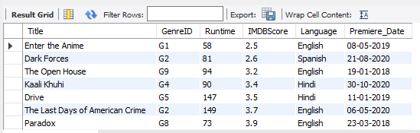

TASK 6:
Find all movies that either have a runtime less than 60 minutes or an IMDb score less than 5, sorted by Premiere Date.
Query:
Select Title,Runtime,IMDBScore from netflix_originals where Runtime<60 Or IMDBScore<5 order by Premiere_date ;
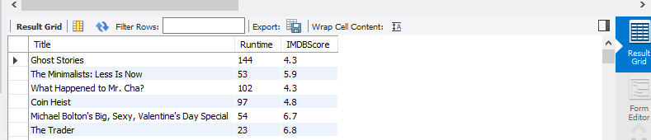
Task 7:
Get the average IMDb score for each genre where the genre has at least 10 movies.
Query:
select GenreID,Avg(distinct IMDBScore) as avg_IMDBScore from netflix_originals group by GenreID having count(GenreID)>10;
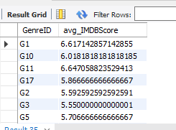

TASK 8:
Retrieve the top 5 most common runtimes for Netflix Originals.
Query
Select * from netflix_originals order by Runtime Desc limit 5;
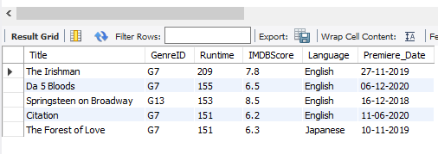
TASK 9:
List all Netflix Originals that were released in 2020, grouped by language, and show the total count of titles for each language.
Query:
Select Language,count(distinct Title) as total_title from netflix_Originals where Premiere_date like '%2020' group by Language order by total_title Desc;
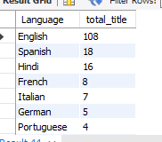
Task 10
Create a new table that enforces a constraint on the IMDb score to be between 0 and 10 and the runtime to be greater than 30 minutes
Query
Create table Netflix
(
Title varchar(255) Not null,
GenreID varchar(10) not null,
Runtime int check (Runtime>30),
IMDBScore double check (IMDBSCORE>10),
Language varchar(255),
Premiere_Date date
);

